14

!II

P.O. Box 798 Ansted, West Virginia 25812
Stephen Pridemore, Mayor Telephone 304-658-5901

FAX 304-658-4680
"A West Virginia Blueprint Communi ty"

Siobhan Wilson, Recorder

The Town of Ansted held a Planning Meeting on Thursday, October 21, 2021.
Those present were Mayor Steve Pridemore, Recorder Siobhan Wilson, Councilmembers Josh Cameron, Robbie Wilson, Wayne Hogg, and Holly Jeffers. Councilman Johnny Osborne attended the meeting via Zoom. Also present was Chief of Police Willilam Willis, Maintenance Supervisor Donnie Wilson, Sanitary Board Chair Jacky Willis, and one citizen. Mayor Pridemore called the meeting to order at 6:00 PM.

Mayor Pridemore informed Council that the Town's application for Home Rule has been approved and we just need to finish the zip+4 information and submit it to the state to be complete. The one percent sales tax will hopefully start in July of 2022.

The Mayor announced that in the next two weeks bid requests for the sewer upgrade project should start being advertised. The Mayor, also, said that he'd had a meeting with Region 4 and the New River Gorge Regional Development Authority and they were confident they could find funding for the Ames Heights addition to the sewer project.

Several calls have been made to different companies about giving the Town quotes for the storm water projects for the American Rescue Plan Act Funds. However, no one has returned calls or placed a bid. The Mayor said that the Town will now try to solicit bids by placing an ad on the Town's Facebook page, website, and in the local paper.

The Town Hall remodel project still has not started yet. The Maintenance Supervisor said that maintenance will be busy with street projects for the next couple of weeks so the Mayor will try to get in contact with the prison again to see if they have workers available.

Chief Willis announced that the period for accepting applications for the Police Department closed at 4 PM and that he will hold a PT test for all who applied on November 13, 2021, at Midland Trail High School. Everyone that passed the PT test will then go on to open interviews with Council. A hiring committee consisting of Josh Cameron, Holly Jeffers, and Johnny Osborne will then make the final decision on who to nominate for the position.

The Mayor and Councilman Osborne attended the SIC meeting with Smithers and Montgomery and felt that for the Town to join SIC would be beneficial. And even if we don't join, we could possibly still share resources such as the police department, expenses, employees (code enforcement officer, grant writer, IT personnel, etc.), and
Page 1 of3.

15

equipment. In order to join, the Town must have the Mayor, a councilperson, and business owner in Ansted join the SIC board. The final decision to join is on hold while UKVSIC checks the bylaws, etc. to check the legality of Ansted joining.

The Mayor discussed putting in place a Comprehensive Plan for the Town of Ansted. The Town doesn't currently have one and he would like to check into having the Land Use and Sustainable Development Law Clinic help us put one together with the help of the future "Vision Committee". For the Vision Committee the Mayor would like to put together a group of 5-7 people.

Since the Town doesn't currently have any ordinances on the books for RV/Campgrounds, Robbie Wilson made a motion to send the information to Town Attorney Brian Parsons so that he can draft an ordinance for the Town. Wayne Hogg seconded the motion and it passed unanimously.

Johnny Osborne gave an update on the Rim to River Race happening on November 6, 2021, and let Council know that he has several volunteers already but will need a few more, the gas tanks are fueled and ready to provide heat, and that it should last approximately from 10 AM until Midnight.

The Mayor said the Town was invited to join Southern WV and that the cost is
$50 per year and that the organization helps with tourism and advertising. Robbie Wilson made a motion for the Town to join Southern WV, Josh Cameron seconded, and the motion passed unanimously.

The Mayor and Council wanted to discuss the maintenance department. Robbie Wilson made a motion to go into executive session to discuss issues in maintenance.
Wayne Hogg seconded. Motion was unanimous. Siobhan Wilson was excused and not part of the session.

Council came back out of executive session and Robbie Wilson made a motion to move Kenneth Cecil into a full-time position with a $0.50 per hour pay increase effective November 1, 2021, and to extend temporary employment to Rob Wilson until January 31, 2022. Johnny Osborne seconded the motion, but it was not unanimous. Those forthe motion were Steve Pridemore, Josh Cameron , Robbie Wilson, Wayne Hogg, Holly Jeffers, and Johnny Osborne. Siobhan Wilson abstained .

With no further business to conduct, Robbie Wilson made a motion to adjourn the meeting. Wayne Hogg seconded. Motion was unanimous.

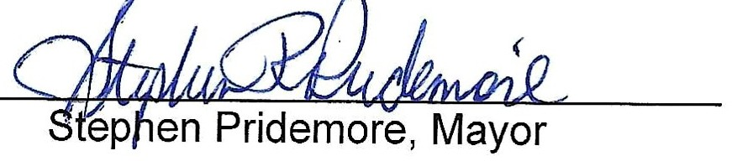
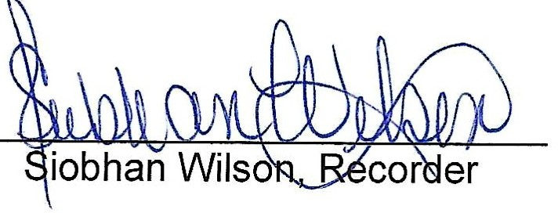

I1>wn ofAnsted Planning Meeting October 2021

